Contents

Integration Techniques 1

Exponent 1

Trig 2

Exponent and Trig 2

16.1 Line Integrals 2

Parametrizing Techniques 2

Straight Line 2

16.3 Path Independence, conservative fields, potential functions 2

14.9 Taylor’s Formula 2

Error(estimate remainder) 3

****Differential Roots Reference for complementary solution 2

Ch 3.6: Forced Oscillations and Resonance 2

Ch 3.7: Electrical Circuits 2

Strategies 3

Ch 4.1: Laplace Transform: 2

Integration strategies: 3

t(e^-st) 3

Trig 3

Trig and Exponent 3

T*cos(3t) 🡪 variable * trig 3

Inverse LaPlace 3

(Constant / s^2) + ….. + (constant / s^n) 3

Constant / s^2 + constant 3

Constant / (s+5)(s-4)… 3

Unit Step Function 3

Ch 4.2 Laplace Initial Value Problems 2

5.1 Power Series 3

# Integration Techniques

## Exponent

* Always do a sub let u = whatever is the exponent, it will reduce mistakes

## Trig

* Cos(2x) -> sin(2x)/2
* (cos(x))^2 -> ½ + cos(2t)/2
* **Trig Properties**
  + <https://www.google.com/search?q=trig+properties&safe=active&client=firefox-b-d&sxsrf=ALeKk03Y9JaPgp6qqRNc33VWfyA5cX_0Lw:1596502828116&tbm=isch&source=iu&ictx=1&fir=f7gvVUgE2U7ApM%252CtLqZv26ycOAyVM%252C_&vet=1&usg=AI4_-kR7Ypv3thaydrLHiTnrPV5Meci-cw&sa=X&ved=2ahUKEwiAks-_rIDrAhVNnp4KHcjfCjoQ9QEwAHoECAUQMA&biw=1536&bih=722#imgrc=f7gvVUgE2U7ApM>

## Exponent and Trig

* e^x * cos(x) 0 -> do integration by parts twice in a row

u = e^t

dv = cos t

# 16.1 Line Integrals

## Parametrizing Techniques

### Straight Line

<https://mathinsight.org/line_parametrization_examples>

# 16,2 Vector Fields, Work, Circulation, Flux

* <https://ltcconline.net/greenl/courses/202/vectorFunctions/tannorm.htm>
  + Unit tangent Vector = T
* See pg 963 for table

## Work, Flow, Circulation

* ALL THE SAME THING

## Flux

* See pg 966 for an example

# 16.3 Path Independence, conservative fields, potential functions

* Find the work done
* Compute ▽f (gradient f)
  + It’s just fx **I** + fy **j** + fz **k**
  + Just the partial derivative of the entire function with respect to each dimension. The gradient is still a vector

## Exact vs Conservative Field

* This is the exact same thing
* **Show that the following integral is exact and then solve**
  + See take home final page 5

# 16.4 Green’s Theorem

### Asking For Area



<https://mathinsight.org/greens_theorem_find_area>

**Assignment 3: 1-10**

# 14.9 Taylor’s Formula

* Also used to derive second derivative test for local extreme values see pg 867 and the error formula for linearizations of funtions of two independent variables
* See pg 869 for the formulas at both a point (a,b) and the origin (0,0)
* **Remember to evaluate the derivitives at (a,b) or (0,0).**
* Partial derivative calculator [https://www.symbolab.com/solver/partial-derivative-calculator/](https://www.symbolab.com/solver/partial-derivative-calculator/%5Cfrac%7B%5Cpartial%7D%7B%5Cpartial%20y%7D%5Cleft(e%5E%7Bxy%7Dx%5Ccos%20%5Cleft(x%5E%7B2%7D%2By%5E%7B2%7D%5Cright)-2e%5E%7Bxy%7Dy%5Csin%20%5Cleft(x%5E%7B2%7D%2By%5E%7B2%7D%5Cright)%5Cright))

## Error(estimate remainder)

* Simply calculate the next little order of the order you’re supposed to do. For example if you are on order 2, simply calculate the order 3 formula on it’s own.
  + See pg 870

# ****Differential Roots Reference for complementary solution

Pg 163 – pg 170

# Ch 3.6: Forced Oscillations and Resonance

* <https://math.libretexts.org/Bookshelves/Differential_Equations/Book%3A_Differential_Equations_for_Engineers_(Lebl)/2%3A_Higher_order_linear_ODEs/2.6%3A_Forced_Oscillations_and_Resonance>
* **Damping chart** https://ocw.mit.edu/courses/mathematics/18-03sc-differential-equations-fall-2011/unit-ii-second-order-constant-coefficient-linear-equations/damped-harmonic-oscillators/MIT18_03SCF11_s13_2text.pdf
* Pure resonance when w = wo
* Undamped is when c = 0
  + This makes the equation mxII+kx = F(0) cos(wt)

# Ch 3.7: Electrical Circuits

* See tutorial 8
* See main formulas pg 210
* Remember this is just finding yc and yp.
  + Yc you’re getting complex roots from homogenous equation
  + Yp you’re subbing in a guess from. **See link below for good particular solution guessing**
  + https://www.youtube.com/watch?v=qiE_mLjXhXM

## Strategies

* Remember to do both yc and yp for Q(t) which will be the initial equation.
* If the differentiation is super ugly remember equation 4, where you can get yc and yp for I(t).
  + At this point if both Q(0) = I(0) = 0, then you would be able to solve for c1 and c2 separately in your yc.
  + Yp will able to be solved since you’ve already found A and B to sub back into your guessed formulas
* Look on pg 191 for yp undetermined if there are duplicates
* Look on pg 194 for yp variation of parameters if needed

# Ch 4.1: Laplace Transform:

* Tutorial 9
* Assignment 11
* Main Formula pg 230
* pg 234 – Short table of laplace transforms
* **Laplace Tranform Theorems** - <https://www.chegg.com/homework-help/questions-and-answers/3-using-laplace-transform-pairs-table-21-properties-laplace-transform-table-22-derive-lapl-q34453635>
* Chapter 7 in Chegg. Lots of questions in 7.1 -> 11ish
* **LOOK AT THE TABLE FIRST**

## Integration strategies:

### t(e^-st)

* Use integration by parts

u = t

dv = e^-st

### Trig

* Going to have to use integration by parts
* Quick look on pg 233

### Trig and Exponent

* Use a theorem leading to F(s-a), see tut 9 q1d
* 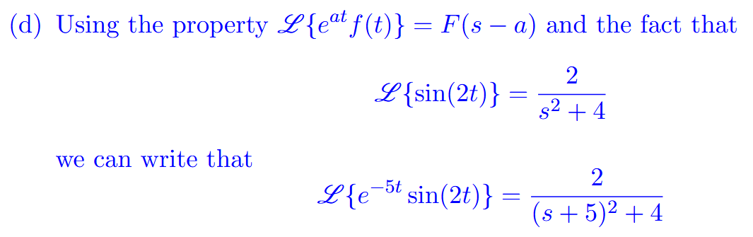

### T*cos(3t) 🡪 variable * trig

<https://www.youtube.com/watch?v=1KEdneLhLZ0>

## Inverse LaPlace

* Try to expand F(s) as much as possible
* Table: <https://www.google.com/search?q=laplace+inverse+table&safe=active&client=firefox-b-d&sxsrf=ALeKk00lolqEIZFlzPYcd_iDBA79EUs-ZA:1596331354461&tbm=isch&source=iu&ictx=1&fir=y3LUpH6F_NiciM%252CVJBZXfpnHjTonM%252C_&vet=1&usg=AI4_-kQ9htD7jhHwwZttch87rJ18oiYKuQ&sa=X&ved=2ahUKEwjp583arfvqAhVxJDQIHY3WCEcQ9QEwAHoECAYQHA&biw=1280&bih=578#imgrc=y3LUpH6F_NiciM>

### (Constant / s^2) + ….. + (constant / s^n)

* See 3rd entry of table corresponding to t^n

### Constant / s^2 + constant

* Get it to look like a sin kt part of the table

### Constant / (s+5)(s-4)…

* Need to use partial fractions to separate things. Look at tutorial 9

### Unit Step Function

* Pg 234
* Tutorial 9 q 3

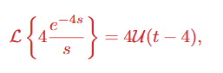**NOTE THAT IT IS AN INVERSE, IGNORE THE lack of -1**

# Ch 4.2 Laplace Initial Value Problems

# 5.1 Power Series

* Find two linearly independent power series solutions of the given differential equation. Determine the radius of convergence of each series, and identify the general solution in terms of familiar elementary functions.
  + See assignment 10 homework
  + <https://www.youtube.com/playlist?list=PLj7p5OoL6vGxVRuGGaoAnDw2LCylUUzCi>

1. YII+16y = 0
   * **Step 1**
     + Sub in the values of the power series with derivatives
   * **Step 2**
     + Shift in the index of summation to have all xn and all the summations with the same beginning to you can factor both out. This will lead to getting the ***recurrence relation***
   * **Step 3**
     + Test the recurrence relation with n=0,1,2,….. to develop a pattern
   * **Step 4**
     + Sub the values of c1,2,3,…… into the original power series equation to get rid of the coefficients.
   * **Step 5**
     + Determine the c0 and c1­ by factoring them out. There are your two linearly independent power series solutions